**ITS 26000 – Applied Database Tech**

**Lab 12 – (100 points)**

**Use SQL to complete the following exercises.**

### **KimTay Pet Supplies:**

* 1. During class time, we run the following statement:

You can see that “Invoice_date+7”’s return values are displayed in the format “YYYYMMDD” where “YYYY” is the year, “MM” is the month, and “DD” is the day. Could you change the displaying format of “Invoice_date+7” in the same format as “Invoice_date”, which is “YYYY-MM-DD”?

Please write your statement and paste screenshot.  (10 points)

select invoice_date,

date_format(invoice_date + 7, "%Y-%m-%d") a

from invoices;

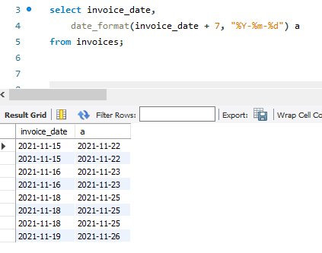

* 1. List the item ID and description for all items. The descriptions should appear in uppercase letters. (5 points)

select item_id, upper(description)

from item;

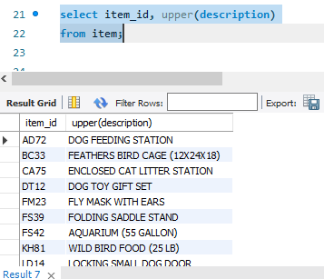

* 1. List the customer ID, first and last names, and balance for all customers. The balance should be rounded to the nearest dollar. (5 points)

select cust_id, first_name, last_name, ceiling(balance) as balance

from customer;

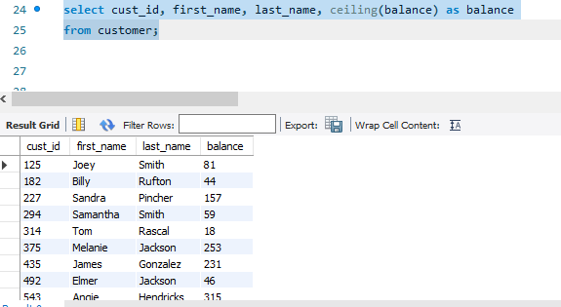

* 1. KimTay Pet Supplies is running a promotion that is valid for up to 20 days after an order is placed. List the invoice number, customer ID, customer first and last names, and the promotion date for each invoice. The promotion date is 20 days after the invoice was placed. (10 points)

select b.invoice_num, b.cust_id, a.first_name, a.last_name, b.INVOICE_DATE, date_add(b.invoice_date, interval 20 day) as promotion_date

from customer a, invoices b

where a.cust_id = b.CUST_ID

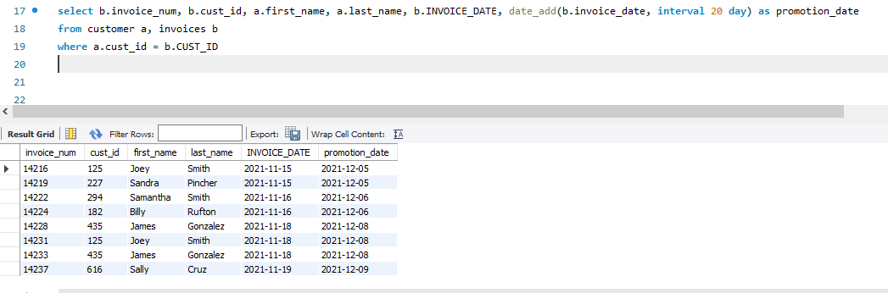

* 1. Write MySQL, PL/SQL, or T-SQL procedures to accomplish the following task:

Obtain the name and credit limit of the customer whose ID currently is stored in I_CUST_ID. Place these values in the variables I_CUSTOMER_NAME and I_CREDIT_LIMIT, respectively. Output the contents of I_CUSTOMER_NAME and I_CREDIT_LIMIT. (15 points)

delimiter //

create procedure e(in i_cust_id varchar(3),

out i_customer_name varchar(41),

out i_credit_limit decimal(7,2))

begin

select concat(first_name, " ", last_name), credit_limit

into i_customer_name, i_credit_limit

from customer

where cust_id = i_cust_id;

end //

DELIMITER ;

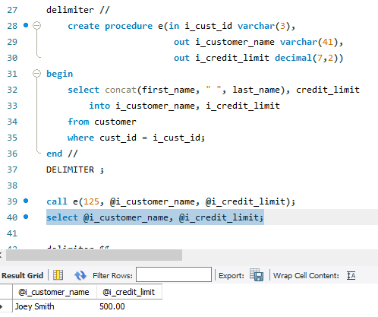

* 1. Write MySQL, PL/SQL, or T-SQL procedures to accomplish the following task:

Obtain the invoice date, customer ID, and first and last names for the invoice whose number currently is stored in I_INVOICE_NUM. Place these values in the variables I_INVOICE_DATE, I_CUST_ID, and I_CUST_NAME, respectively. Output the contents of I_INVOICE_DATE, I_CUST_ID, and I_CUST_NAME. (15 points)

delimiter *

create procedure f(in i_invoice_num char(5), out i_invoice_date date, out i_cust_id varchar(3), out i_cust_name varchar(41))

begin

select a.invoice_date, b.cust_id, concat(first_name, " ", last_name)

into i_invoice_date, i_cust_id, i_cust_name

from invoices a, customer b

where i_invoice_num = a.invoice_num and b.cust_id = a.cust_id;

end *

delimiter ;

call f(14216, @i_invoice_date, @i_cust_id, @i_cust_name);

select @i_invoice_date, @i_cust_id, @i_cust_name;

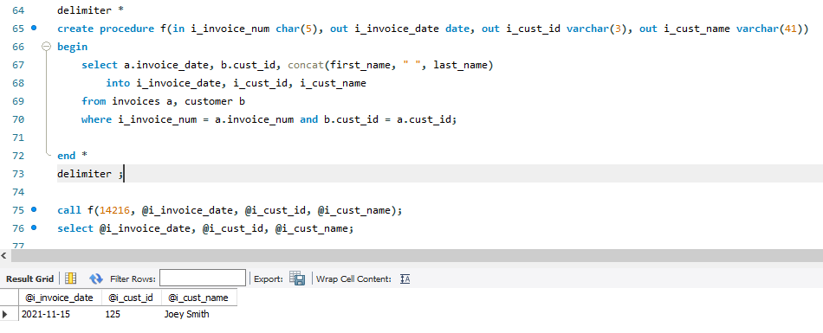

1. **StayWell Student Accommodation:**
   1. StayWell is offering a monthly discount for residents who pay their rent on a quarterly basis. The discount is 1.75 percent of the monthly fee. For each property, list the office number, address, owner number, owner’s last name, monthly rent, and discount. The discount should be rounded to the nearest dollar. (10 points)

select office_num, a.address, a.owner_num, b.last_name, monthly_rent, monthly_rent * 0.0175 as discount

from property as a, owner as b

where a.owner_num = b.owner_num;

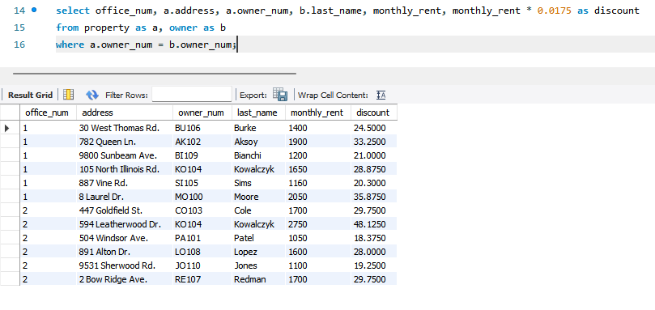

* 1. Write PL/SQL or T-SQL procedures to accomplish the following task:

Obtain the first name and last name of the owner whose number currently is stored in I_OWNER_NUM. Place these values in the variables I_FIRST_NAME and I_LAST_NAME. Output the contents of I_OWNER_NUM, I_FIRST_NAME, and I_LAST_NAME. (15 points)

delimiter //

create procedure b(in i_owner_num char(5), out i_first_name varchar(20), out i_last_name varchar(20))

begin

select first_name, last_name

into i_first_name, i_last_name

from owner

where owner_num = i_owner_num;

end //

delimiter ;

call b('AK102', @i_first_name, @i_last_name);

select @i_first_name, @i_last_name;

* 1. Write PL/SQL or T-SQL procedures to accomplish the following task:

Obtain the office number, address, owner number, owner first name, and owner last name for the property whose property ID is currently stored in I_PROPERTY_ID. Place these values in the variables I_LOCATION_NUM, I_ADDRESS, I_OWNER_NUM, I_FIRST_NAME, and I_LAST_NAME, respectively. Output the contents of I_PROPERTY_ID, I_ADDRESS, I_OWNER_NUM, I_FIRST_NAME, and I_LAST_NAME. (15 points)

**Deliverables**: Document Report with the SQL statement/Query and snapshot of query, its execution and results. Either word or pdf file need to be uploaded into Brightspace in one submission